

**Green University of Bangladesh**

**Department of Computer Science and Engineering (CSE)**

**Faculty of Sciences and Engineering**

**Semester: (Summer, Year:2022), B.Sc. in CSE (Day)**

**Course Title: Data Communication Lab**

**Course Code: CSE 308 Section: 201 D 10**

**Lab Project Name: Home Automation Using ARDUINO UNO & Android App.**

**Student Details**

|  |  |  |
| --- | --- | --- |
| **Name** | | **ID** |
| **1.** | Md. Obaydullah Khan | 201002093 |
| **2.** | Khaled Mahmud Saoun | 201002096 |

**Submission Date : September 9, 2022**

**Course Teacher’s Name : Mr. Md. Rajibul Palas**

**[For Teachers use only: Don’t Write Anything inside this box]**

|  |
| --- |
| **Lab Project Status**  **Marks: ………………………………… Signature: .....................**  **Comments: .............................................. Date: ..............................** |

Table of Contents

Chapter 1 Introduction 3

1.1 Introduction 3

1.2 Design Goals & Objective 3

Chapter 2 Implementation of the Project 4

2.1 Device and Components for this project 4

2.2 Device and Components Details 7

Chapter 3 Performance Evaluation 11

3.1 Simulation Procedure 11

3.2 Results and Discussions 12

Chapter 4 Conclusion 13

4.1 Introduction 13

4.1 Practical Implications 13

4.2 Scope of Future Work 13

References 14

# Chapter 1 Introduction

## Introduction

This project presents a design and prototype implementation of home automation system that uses Bluetooth [1] technology as a network infrastructure connecting its parts. The proposed system consists of two main components; the first part is the server (web server), which presents system core that manages, controls, and monitors users’ home.

Users and system administrator can locally (LAN) or remotely (internet) manage and control system code. Second part is hardware interface module, which provides appropriate interface to sensors and actuator of home automation system.

Unlike most of available home automation system in the market the proposed system is scalable that one server can manage many hardware interface as long as it exists on W network coverage. System supports a wide range of home automation devices like power management components, and security components. The proposed system is better from the scalability and flexibility point of view than the commercially available home automation systems.

## Design Goals & Objective

Some days before we discussed about automation[2] and remote control via internet. We are talking about controlling our computer from remote place or anywhere in this world, there are many software for controlling computer from remote place but there is a problem too. Those software can only work when the computer is turned on. But always on Computer is miss use of electricity too. Beside our electricity is not stable. We face load shading without any notice. So when our power will cut off then we can not control our computer again. After that we are thinking to make something that can turn on any electronic device from remote place and we know about home automation.

* The goal of this project is to develop a home automation system that gives the user complete control over all remotely controllable aspects of his or her home.
* The automation system will have the ability to be controlled from a central host PC, the Internet, and also remotely accessed via a Android Mobile based application.

# Chapter 2

# Implementation of the Project

## Device and Components For This Project

In this section we describe all device and components for this project.

* + 1. **Device list**
* Arduino Uno [3]
* Bluetooth Module HC-05 [4]
* Android Phone
* LED
* Jumper Cable (Male-Female)
* Connecting Cable
* USB Cable
  + 1. **Devices Details and Why We Use This Device**
* **Arduino Uno**

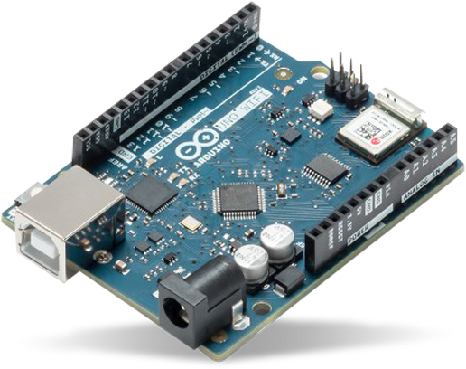

Img : Arduino Uno

**Description**: The Arduino UNO is the best board to get started with electronics and coding. If this is your first experience tinkering with the platform, the UNO is the most robust board you can start playing with. The UNO is the most used and documented board of the whole Arduino family.

**Features:**

Arduino UNO is a microcontroller board based on the ATmega328P. It has 14 digital input/output pins (of which 6 can be used as PWM outputs), 6 analog inputs, a 16 MHz ceramic resonator, a USB connection, a power jack, an ICSP header and a reset button. It contains everything needed to support the microcontroller; simply connect it to a computer with a USB cable or power it with a AC-to-DC adapter or battery to get started. You can tinker with your UNO without worrying too much about doing something wrong, worst case scenario you can replace the chip for a few dollars and start over again.

**Bluetooth Module HC-05:**

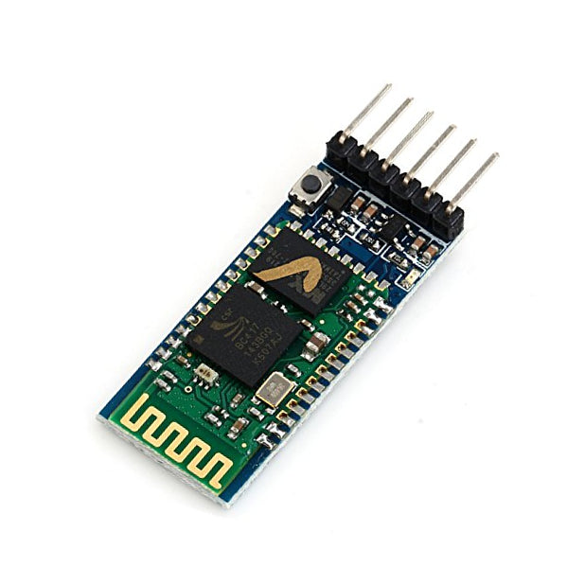

Img : Bluetooth Module HC-05

The **HC-05** is a popular bluetooth module which can add two-way (full-duplex) wireless functionality to your projects. The HC-05 is a popular module which can add two-way (full-duplex) wireless functionality to your projects. You can use this module to communicate between two microcontrollers like Arduino or communicate with any device with Bluetooth functionality like a Phone or Laptop. There are many android applications that are already available which makes this process a lot easier. The module communicates with the help of USART at 9600 baud rate hence it is easy to interface with any microcontroller that supports USART. We can also configure the default values of the module by using the command mode. So if you looking for a Wireless module that could transfer data from your computer or mobile phone to microcontroller or vice versa then this module might be the right choice for you. However do not expect this module to transfer multimedia like photos or songs; you might have to look into the CSR8645 module for that.

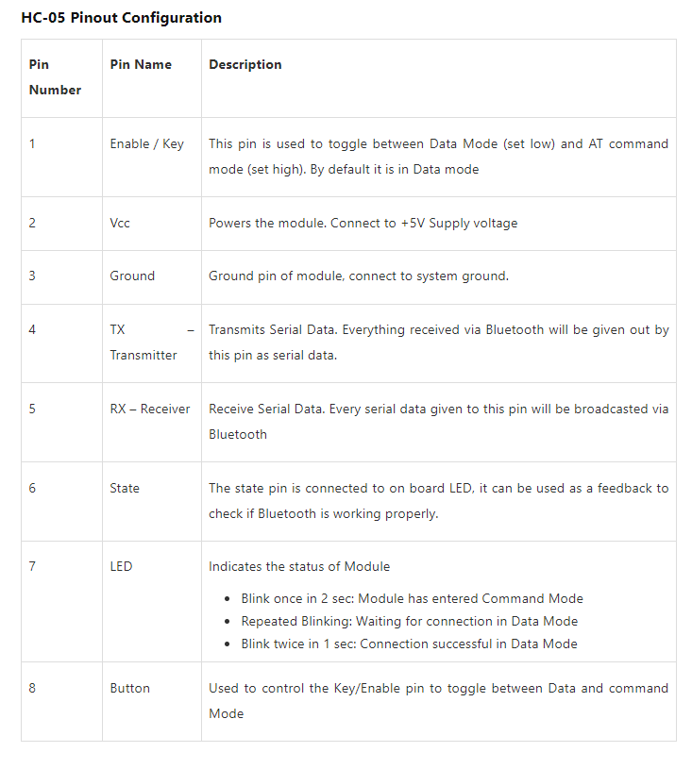

**Features:-**

1. Wireless communication between two microcontrollers

2. Communicate with Laptop, Desktops and mobile phones

3. Data Logging application

4. Consumer applications

5. Wireless Robots

6. Home Automation

**Advantages:**-

* High quality
* Low cost
* No extra power suppl
* Software with many functions
* Control electrical devices according weekday/date/time
* Create timers or pulses with our software

## Implementation

## Hardware part

## The connection of all components shown below by drawing and real life picture:

## Control LED Using Your Voice Command - Arduino Project Hub

## Fig : Connections of all components in Simulation

## 

## Img: Real life Implementation;

## Software part

## 

## Img : 3 Switch Android app for controlling automation

## We will control any electronic device by using this app from any where in the world.

## Arduino code :

unsigned long previousMillis  = 0;

unsigned long interval        = 1000;

bool          LED_BLINK       = false;

void setup() {

  Serial.begin(9600);

  pinMode(LED, OUTPUT);

}

void loop() {

  while( Serial.available() ){

    char command = Serial.read();

    switch(command){

      case 'a':

        digitalWrite(LED, LOW);

        break;

      case 'A':

        digitalWrite(LED, HIGH);

        break;

      case 'b':

        digitalWrite(LED, LOW);

        LED_BLINK = false;

        break ;

      case 'B':

        LED_BLINK = true;

        break;

      case 'c':

        digitalWrite(LED, LOW);

        LED_BLINK = false;

        interval = 1000;

        break ;

      case 'C':

        LED_BLINK = true;

        interval = 200;

        break;

      default:

        Serial.println("Unknown command");

        break;

    }

  }

  if ( LED_BLINK ){

    unsigned long currentMillis = millis();

    if (currentMillis - previousMillis >= interval) {

      previousMillis = currentMillis;

      if (digitalRead(LED) == LOW) {

        digitalWrite(LED, HIGH);

      } else {

        digitalWrite(LED, LOW);

      }

    }

  }

}

## We have flashed this code to our Arduino for controlling home automation.

# Chapter 3 Performance Evaluation

## Simulation Procedure

To run This project at first we have to connect connect the plug with electricity .After that we

Have to powerup Arduino UNO

When Arduino Uno will powered up then we can see a Bleutooth connection named AUTOMATION. We have to connect any communication device like Android mobile or Laptop and then we have to go its user panel by opening web browser. The hosts Address will be 192.168.4.1. Then we can see connect network button and then we will connect our ARDUINO with our local network.  
  
After that Our total connection procedure both hardware-software & software-network connection have done.

Now we have to go in our Android Application that we have downloaded form playstore, when we turned on switch then microcontrollers signal LED will turned on and It means The microcontroller is working successfully and lite up the connected LED.

## Results and Discussions

* + 1. **Results**

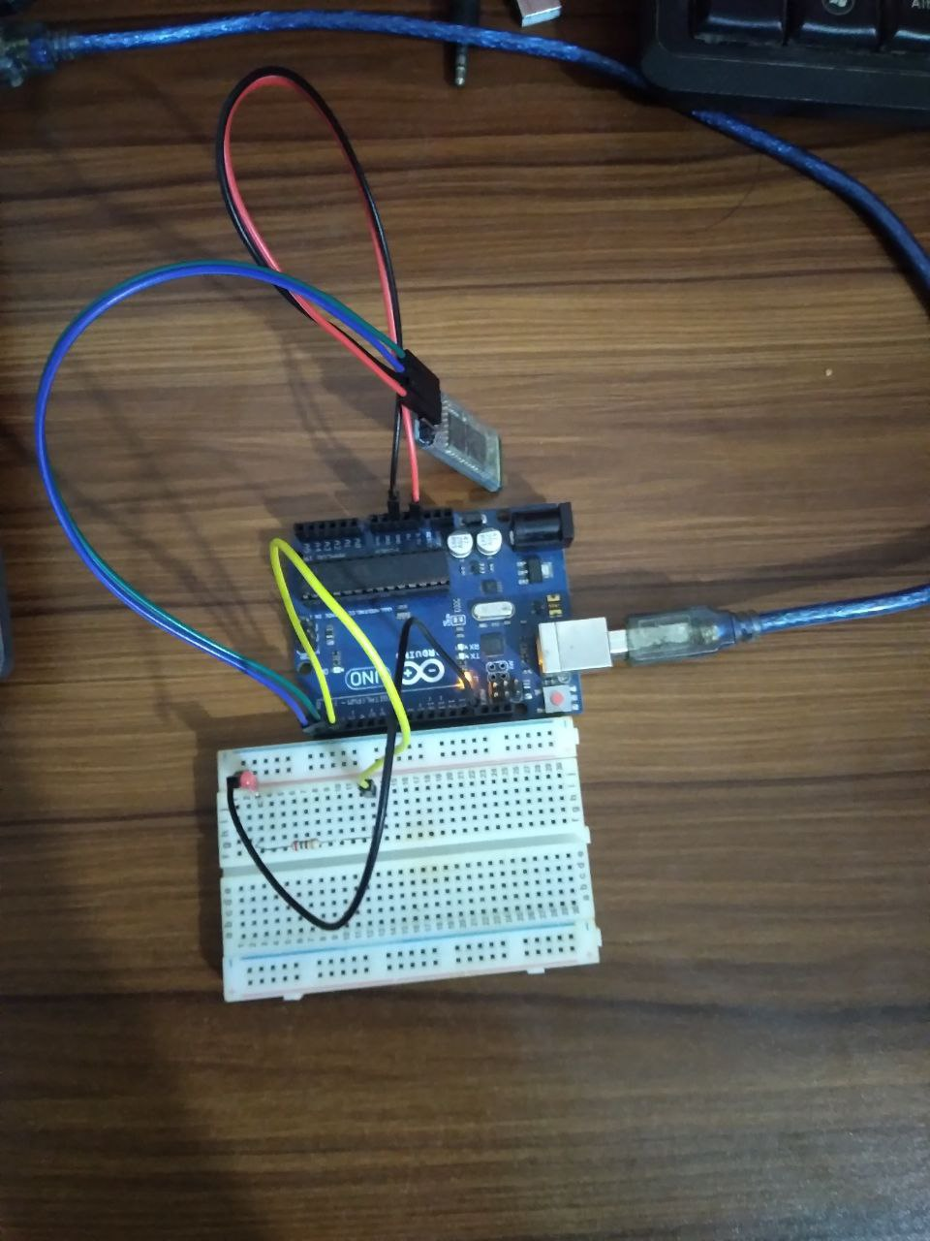

Img: Final result of Home Automation using ESP 8266 and Android app

* + 1. **Analysis and Outcome**

This is a useful project for home , office , school , university or any others place. The mobile application based home automation is very easy to control an also setting up is easy. If anyone want to Implemet this in his home he must be have a relay module with more than 4 channel ( here 4 channel mean he can control four device) , he also must have stable Internet connection for controlling Automation.

# Chapter 4 Conclusion

## Introduction

At the time of global village or time of internet. This time everyone want to be connect with everyone and everyone like automation or remote working. This project will fully allow user to control electronic device remotely.

## Practical Implications

This project is very useful project for home, office , school , college , university or any other place. Every place in this world is now under coverage of electricity and internet, and there are many place where we miss use electricity by not turning electronic device off in right time. If we use home automation , we can timely turn of our un wanted electronic device and can save more electricity .

Beside everyone want automation for their classy life , and this device can make life more easier.

We can use more channel relay device to cover more device under this automation process.

## Scope of Future Work

Day by day, the field of automation is blooming and these systems are having great impact on human beings. The project which is to be implemented is a home automation using Easy IOT Webserver and WIFI and has very good future development. In the current system webserver is installed on a windows PC so the home appliances can be controlled using only by using the device on which webserver is installed.This can be further developed installing webserver on cloud . Advantage of installing webserver on the cloud is that home can be controlled by using any device which has WIFI 802.1 and a web browser. By visiting the IP address of the cloud the control actions can be taken.

# References

1. Garber, Megan (23 June 2014). "'Why-Fi' or 'Wiffy'? How Americans Pronounce Common Tech Terms". The Atlantic. Archived from the original on 15 June 2018.A. Rezi and M. Allam, ”Techniques in array processing by means of transforma- tions, ” in Control and Dynamic Systems, Vol. 69, Multidemsional Systems, C. T. Leondes, Ed. San Diego: Academic Press, 1995, pp. 133-180.
2. Groover, Mikell (2014). Fundamentals of Modern Manufacturing: Materials, Processes, and Systems.K. Schwalbe, Information Technology Project Management, 3rd ed. Boston: Course Technology, 2004.
3. "ESP8266 Overview". Espressif Systems. Retrieved 2017-10-02.
4. https://mysite.du.edu/~jcalvert/tel/morse/morse.htm#H1